The Use of Explicit Health Benefits Packages Increases Support for Universal Health Care for People with High Objective Numeracy

Bayesian methods are becoming increasingly used in applied psychology research. Previous researchers have thoroughly written about much of the details already, including the philosophy underlying Bayesian methods, computational issues associated with Bayesian model estimation, Bayesian model development and summary, and the role of Bayesian methods in the so-called replication crisis. We do not attempt to rehash these topics in this paper, but instead seek to provide case studies comparing the use of frequentist methods to the use of Bayesian methods in applied psychological research. These case studies are intended to “illustrate by example” the ways that Bayesian modeling differs from frequentist modeling, and the differing conclusions that one may arrive at using the two methods. The intended audience is applied psychology researchers who have been trained in the traditional frequentist framework, and who are curious about how statistical results might look different in a Bayesian context. Along with our case studies, we provide general opinions and guidance on the use of Bayesian methods in applied psychology research.

# Seed for random number generation  
set.seed(42)  
knitr::opts_chunk$set(cache.extra = knitr::rand_seed)  
knitr::knit_hooks$set(purl = knitr::hook_purl)

# Introduction

# Method

## Participants

Our participants were 189 students enrolled in a Psychology course at a Midwestern University. Our participants were primarily white (76%), female (68%), and freshmen (80%); further demographic information can be found in [Table here]. Participants received course credit for participation in the study.

|  |  |  |  |  |
| --- | --- | --- | --- | --- |
| **Characteristic** | **Active Intervention**, N = 60 | **No Intervention**, N = 62 | **Passive Intervention**, N = 63 | **p-value** |
| **Age** | 18.55 (0.70) | 18.44 (0.93) | 18.37 (0.63) | 0.13 |
| **Sex** |  |  |  | 0.7 |
| Female | 36 / (60%) | 41 / (66%) | 42 / (67%) |  |
| Male | 24 / (40%) | 21 / (34%) | 21 / (33%) |  |
| **Race** |  |  |  | >0.9 |
| Caucasian/White | 46 / (77%) | 49 / (79%) | 48 / (76%) |  |
| African-American/Black | 5 / (8.3%) | 5 / (8.1%) | 6 / (9.5%) |  |
| Asian/Pacific Islander | 3 / (5.0%) | 3 / (4.8%) | 3 / (4.8%) |  |
| Caucasian/White,Asian/Pacific Islander | 2 / (3.3%) | 4 / (6.5%) | 1 / (1.6%) |  |
| Caucasian/White,African-American/Black | 1 / (1.7%) | 1 / (1.6%) | 1 / (1.6%) |  |
|  | 2 / (3.3%) | 0 / (0%) | 0 / (0%) |  |
| Other | 1 / (1.7%) | 0 / (0%) | 1 / (1.6%) |  |
| African-American/Black,American Indian/Alaska Native | 0 / (0%) | 0 / (0%) | 1 / (1.6%) |  |
| African-American/Black,Hispanic/Latino(a) | 0 / (0%) | 0 / (0%) | 1 / (1.6%) |  |
| Hispanic/Latino(a) | 0 / (0%) | 0 / (0%) | 1 / (1.6%) |  |
| **School Year** |  |  |  | 0.2 |
| Freshman | 47 / (78%) | 52 / (84%) | 53 / (84%) |  |
| Sophmore | 8 / (13%) | 6 / (9.7%) | 8 / (13%) |  |
| Junior | 5 / (8.3%) | 1 / (1.6%) | 2 / (3.2%) |  |
| Senior | 0 / (0%) | 3 / (4.8%) | 0 / (0%) |  |

## Procedure

Participants were randomly assigned to one of three conditions representing different exposure to health benefits information. Our three conditions were an ‘active’ intervention condition (n=60), a ‘passive’ intervention condition (n=62), and our control condition (n=63). The two intervention conditions consisted of a packet of exercises adapted from the Choosing Healthplans All Together (CHAT) paradigm developed by Danis, Biddle & Goold (2002). CHAT is a simulation exercise where participants construct their own HBP by allocating a limited set of resources to benefit types (e.g. dental) and choosing scope of coverage (basic-to-high). The HBP as a whole is represented by a ‘game board’ with several sections representing the different benefit types and with the scope of coverage represented by subdivisions in those sections. Each of these sections can be added to the HBP by paying a cost in markers representative of it’s approximate relative cost in the US. For example, if a subject desired ‘basic’ dental care (regular cleanings and examinations every 6 months, with minimal dental care), it would cost 2 markers. If the participant desired to upgrade to ‘medium’ dental care (everything in ‘basic’, plus complete dental care including repairs and crowns), that would cost 4 additional markers, bringing the total cost to 6 markers. Participants have a total of 47 markers to use to design their HBP. Trade-offs are enforced as complete coverage is not possible with the limited resources. The core of the exercise is a simplified version of choosing priorities for a health care system.

Our active intervention condition had participants creating their own HBP through the CHAT exercise, while our passive intervention condition had participants being given a completed CHAT exercise. The HBP in our passive intervention condition, consisted of the consensus choices for health insurance found by Danis et al. (2002). Our control condition was similar to the active intervention condition, but mentions of health care are replaced with pizza topping choices instead. Trade-offs are still enforced due to limited resources. This results in an exercise of similar length and intensity that is intentionally uninformative; see Appendix [LETTER HERE] for Study 1 active intervention materials, and [LETTER HERE] for passive intervention materials. Study 1 used a 2 (pre-post) x 3 (condition) mixed-subjects design, where condition was a between-subjects factor and participant were assigned to one of the three conditions. Time was a within-subjects factor with the primary outcome, support for UHC, measured before and after participants completed the control or one of the two intervention conditions.

## Measures

The primary outcome measure was the support for UHC scale, adapted from Shen & Labouff (2013), measured both pre and post-test. The scale was comprised of 4 items measuring support for UHC, which were averaged after reverse scoring the third item (e.g. “Access to medical care and insurance is a basic, inherent right of man”) .Each item was measured on a 7 point Likert scale from 1 (strongly disagree) to 7 (strongly agree); see Table [LETTER HERE] for item wording.

Participants also responded to several items about their experience with health. Participants were asked whether they paid for their own health insurance and if they had ever been uninsured. Participants in the active intervention condition were also asked if they would be happy having the plan they built as their own health insurance. Each of these three items was measured as a ‘yes’ or ‘no’ response. Additionally, there was a free-response question asking about the subjects thoughts about the exercise they just completed. Finally, we also measured demographic information, including gender identity, age, race/ethnicity, and year in school.

## Power and Statistical Analyses

We planned to recruit 180 participants. Sample size was determined a-priori using G-power with the following parameters: greater than 90% power to determine a significant large-sized effect (Cohen’s f = 0.10) at an alpha level of .05, for a linear multiple regression. Support for UHC outcome was treated as a continuous variable. We examined the effects of experimental condition (active intervention, passive intervention, and control ) and time (pre vs. post) on our outcome variable by testing multi-level models with random and fixed intercepts. The linear mixed model we constructed had condition, time, and the condition x time interaction as our fixed effects. A random intercept for each of the subjects was included to account for within-subject correlation in scores. We examined the main effect and the 2-way interaction between our two predictors. Additionally, we also All tests were conducted in R and were considered statistically significant when P < .05.

Additionally, we fitted Bayesian linear multivariate multilevel models to our support for UHC outcome variable as a function of dummy-coded factors ‘condition’ (reference level ‘control’), and ‘time’ (reference level ‘pre’) as well as the ‘condition x time’ two way interaction using the Stan modeling language and the R package brms. Condition, time, and their interaction were our fixed effects, with a random intercept for subjects as our random effect. Our priors were a normal distribution with a mean of 0 and a standard deviation of 2.5 for the mean of our reference levels for our three fixed effects. We used the brms package’s default priors for standard deviations of our random effects (Student’s t-distribution with nu = 3, mu = 0 and sigma = 20), as well as for correlation coefficients in interaction models.

## Study 1 Hypothesis:

Hypothesis 1 – The experimental groups will differ in support for UHC.

H1a: Participants in the two intervention conditions will have greater increases in support for UHC compared to those in the control condition. We believe this to be the case due to HBPs directly addressing several common sources for opposition to UHC.

H1b: Participants in the active intervention condition will have greater increases in support for UHC than participants in the passive intervention condition. We believe this to be the case as previous research indicates that complex, subject specific, numerical information is more easily learned through active engagement with the material.

# Results

#note should we make sure to actually directly ref these results?

Descriptive statistics are summarized in [Table here]. Our hypothesis was tested using a linear mixed model fitted to our support for UHC outcome measure. Cronbach’s alpha for the items in this measure was 0.85. In opposition to H1a and H1b, we observed no statistically significant effect in our planned comparison of our active intervention condition t(198.5) = 1.22 ,p = .224, or our passive intervention condition t(198.5) = 1.04 ,p = .299. Additionally, we observed no statistically significant effect in our planned comparison of time t(181) = 1.00 ,p = .317. Finally, we also saw no significant interaction between time and the active condition t(181) = 1.14 ,p = .258, or the passive condition t(181) = 1.67 ,p = .0963.

For our Bayesian estimation, we had four sampling chains, each with 2000 iterations and 1000 warmup repetitions. This yielded 4000 estimated samples at convergence. Participants in our uninformative control condition had no significant change in support for UHC post intervention (℮ = 4.78, CI =4.49, 5.07) than pre intervention (℮ = 4.84, CI =4.55, 5.13). Participants in our ‘active’ experimental condition had no difference in support for UHC post intervention (℮ = 5.03, CI =4.74, 5.32) than pre intervention (℮ =5.19, CI =4.90, 5.48). Participants in our ‘passive’ experimental condition had no difference in support for UHC post intervention (℮ =4.99, CI =4.70, 1.34) versus pre intervention (℮ = 5.21 , CI =4.92, 5.50). In support of H1a, participants in both intervention conditions had greater support for UHC compared to the control. However, in opposition to H1b, participants in our active intervention condition did not have a greater increase in support for UHC compared to our passive condition.

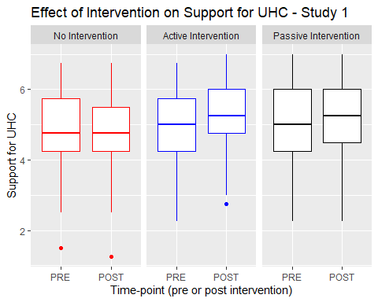

Boxplot showing effect of interventions on support for UHC

## Qualitative results

Analyzing our free-response question, we found several positive and negative trends in our findings. Some participants felt that the pencil and paper exercise was unnecessarily complex, and that the process of completing it was not self-explanitory. Several occasions occurred wherein the participant asked the administrator how to complete the exercise, after having read through the instructions. In total, 10% of participants expressed some form of confusion in their free response segment, e.g.  > “It was a little confusing if you aren’t very familiar with insurance and health care.”

“The way that plan was laid out with the pegs was slightly confusing and I think that it might provide more accurate answers if it were formatted more clearly. Otherwise, I thought that the different levels of care were described well and gave a good picture of what would be provided.”

However, a larger proportion of our participants also found the exercise particularly engaging, interesting, fun, and helpful. In total, 32% of participants expressed some form of positive engagement with the intervention conditions in their free response segment, e.g.

“I think that is was a good exercise to see what kind of benefits you would want and think about what benefits other people should have also”

“It was fun trying to make those decisions. I ended up not bubbling any of the ‘long term’”retired person" options because I just don’t care enough for those benefits. Maybe it’s because I’m not in that situation yet.”

We did not predict a priori that our intervention conditions would increase confusion. Nonetheless, an even larger contingent of our participants expressed positive feelings regarding the exercise. Given that the purpose of the interventions were to increase engagement with the often-times boring information necessary to explain UHC, our qualitative data indicates a positive outcome.

# Discussion

The purpose of Study 1 was to determine if an HBP based intervention would lead to increased support for UHC (H1a). Our secondary aim was to determine if our active intervention condition would have a greater increase in support for UHC than participants in our passive intervention condition (H1b). The results of our linear-mixed model did not support either of our two hypotheses, as the HBP based intervention did not lead to increased support for UHC, and our active and passive intervention conditions had indistinguishable impact. Our Bayesian estimation provided support of our first hypothesis (H1a), indicating that participants in both our intervention conditions had greater support for UHC as compared to our control. However, our Bayesian estimation did not support our second hypothesis (H1b); Participants in our active intervention condition did not have a greater increase in support for UHC compared to our passive condition.

One plausible explanation regarding our conflicting results is the confusion regarding the experimental procedure and materials for participants in our active intervention condition. Primarily, our qualitative free-response section indicated that a significant portion of participants in our active intervention condition did not fully understand the instructions necessary. Considering the complexity and numerical engagement necessary to participate, a lack of understanding could plausibly blunt the impact of the intervention. Furthermore, if participants in our active intervention exhibited confusion, while participants in our passive intervention did not, as they had much simpler instructions, that would be a confounding variable when attempting to determine if active instruction is superior for communicating on UHC as compared to passive instruction.

A significant portion of our participants had expressed difficulties with the experimental protocol and materials. This adds avoidable stochasticity to our data and hinders reproducibility. Therefore, the single largest priority in moving from Study 1 to Study 2 was improving the experimental design and materials. Executing a pseudo-replication of the study, with a protocol that is designed to reduce confusion would significantly reduce potential confounding variables. Additionally, our control condition in Study 1 was an uninformative control, which is not necessarily a realistic comparison point regarding commonly available information on UHC. Thus, the second priority was to alter our control condition to reflect the messaging more accurately on UHC that is already available to improve external validity.

# Method

## Participants

Participants were 412 students enrolled in Psychology 1000 at a Midwestern University. They were primarily white (76%), female (66%), and freshmen (74%); further demographic information can be found in [Table here]. Participants received course credit for participation in the study.

|  |  |  |  |
| --- | --- | --- | --- |
| **Characteristic** | **Control**, N = 195 | **Intervention**, N = 217 | **p-value** |
| **Age** | 18.68 (1.75) | 18.84 (2.08) | 0.3 |
| (Missing) | 1 | 2 |  |
| **Gender** |  |  | >0.9 |
| Female | 127 / (66%) | 146 / (68%) |  |
| Male | 64 / (33%) | 68 / (31%) |  |
| Gender Variant/Nonconforming | 2 / (1.0%) | 2 / (0.9%) |  |
| (Missing) | 2 | 1 |  |
| **Race** |  |  | >0.9 |
| White | 153 / (78%) | 161 / (74%) |  |
| Black | 14 / (7.2%) | 16 / (7.4%) |  |
| APAC | 7 / (3.6%) | 10 / (4.6%) |  |
| Other | 4 / (2.1%) | 7 / (3.2%) |  |
| White,Black | 3 / (1.5%) | 6 / (2.8%) |  |
| White,Hispanic/Latino | 2 / (1.0%) | 5 / (2.3%) |  |
| White,APAC | 3 / (1.5%) | 3 / (1.4%) |  |
| Hispanic/Latino | 2 / (1.0%) | 3 / (1.4%) |  |
| White,American Indian/Alaska Native | 2 / (1.0%) | 3 / (1.4%) |  |
| APAC,Hispanic/Latino | 1 / (0.5%) | 1 / (0.5%) |  |
| APAC,Other | 1 / (0.5%) | 0 / (0%) |  |
| Black,American Indian/Alaska Native | 0 / (0%) | 1 / (0.5%) |  |
| Black,Hispanic/Latino | 0 / (0%) | 1 / (0.5%) |  |
| White,Black,American Indian/Alaska Native,Hispanic/Latino,Other | 1 / (0.5%) | 0 / (0%) |  |
| White,Black,APAC | 1 / (0.5%) | 0 / (0%) |  |
| White,Other | 1 / (0.5%) | 0 / (0%) |  |
| **School Year** |  |  | **0.027** |
| Freshman | 152 / (78%) | 154 / (71%) |  |
| Sophmore | 24 / (12%) | 41 / (19%) |  |
| Junior | 11 / (5.6%) | 19 / (8.8%) |  |
| Senior | 7 / (3.6%) | 1 / (0.5%) |  |
| Other | 1 / (0.5%) | 2 / (0.9%) |  |

## Procedure

Participants were randomly assigned to one of two conditions representing different exposure to health benefits information. Our two conditions were an intervention (n=217) and control condition (n=195). The intervention condition consisted of a web-application adapted from the Choosing Healthplans All Together (CHAT) paradigm used in our ‘active’ condition for Study 1. Participants allocated limited resources to levels and categories of coverage to build an explicit health benefit plan. Due to limited resources, not all categories can be fully covered, leading to forced trade-offs. The content of the intervention condition in Study 2 remains the same, but it is delivered by using a web-application instead of pencil and paper; See Appendix [LETTER HERE] for Study 2 experimental materials. The control condition consisted of informational brochures and pamphlets obtained from the World Health Organization and World Bank containing accurate information on the benefits of UHC; see Appendix [LETTER HERE] for Study 2 experimental materials. Study 2 used a 2 (pre-post) x 2(condition) mixed-subjects design, where condition was a between-subjects factor. Time was a within-subjects factor with the primary outcome, support for UHC, measured before and after participants completed the control or intervention condition.

## Measures

The primary outcome was the support for UHC scale, adapted from Shen & Labouff (2013), measured both pre and post-test. The items included in the scale were the same as in Study 1 (e.g. “Access to medical care and insurance is a basic, inherent right of man”). For Study 2, each item was measured on a 100-point sliding scale from 0 (strongly disagree) to 100 (strongly agree), instead of the 7 point Likert scale used in Study 1. Cronbach’s alpha for the items in this measure was 0.85; see Table [LETTER HERE] for item wording.

Our secondary outcomes were our proposed mediating factors, perceived equality, and comprehensibility, measured both pre and post-test. Perceived equality was a single item measure adapted from Netemeyer, Boles, McKee, and McMurrian (1997) (‘Universal Health Care provides fair and equitable care to all US citizens, regardless of employment status’). The original item measured fairness in reward allocation, in an industrial/ organizational context relative to amount of responsibilities and work. Our adaptation inquires instead about the fairness in the reward analogue of universal healthcare, relative to type and/or amount of employment. Our measure of comprehensibility was adapted from the perceived complexity measure developed by Mulken, Pair, and Forceville (2010). This scale comprised of two items measuring comprehensibility, which are averaged together (‘Universal Health Care is straightforward, ‘Universal Health Care is easy to understand’). The original item measured perceived complexity and comprehensibility in an advertising context, operationalizing the terms by simply asking if the concept is straightforward to easy to understand. Cronbach’s alpha for the items in our measure of perceived complexity was 0.92.

Our moderating variables were subjective and objective numeracy. Objective numeracy was measured using the Rasch Numeracy Scale, created by Weller et al. (2013). This measure consists of 8 items, all math problems of varying complexity, requiring some amount of algebra, percentiles, and table reading skill (e.g. “If it takes five machines 5 minutes to make five widgets, how long would it take 100 machines to make 100 widgets?”). This measure was scored from 0 to 8, with the sum of all correct answers to the individual items as the subject’s objective numeracy score . The Cronbach’s alpha for these items is 0.71 . Subjective numeracy was measured using the Subjective Numeracy Scale created by Fagerlin et al. (2007). This measure is an average eight items Likert-scale items that range from 1 (generally poor with numbers) to 7 (generally prefer numbers) (e.g. “How good are you at calculating a 15% tip?”). The Cronbach’s alpha for these items is 0.84. Additionally, we did not initially collect data on subjective and objective numeracy until part-way through the data collection. Thus, the first 68 subjects do not have this data recorded.

Participants were then asked whether they paid for their own health insurance and if they have been uninsured, and the active intervention condition was asked if they would be happy having the plan they built as their own health insurance. Each of these three items was measured as a ‘yes’ or ‘no’ response. Additionally, there was a free-response question asking about the subjects’ thoughts about the exercise they just completed. Finally, we also measured demographic information, including gender identity, age, race/ethnicity, and year in school.

## Power and Statistical Analyses

We planned to recruit 176 participants. Sample size was determined a-priori using G-power with the following parameters: greater than 90% power to determine a significant large-sized effect (Cohen’s f =0.10) at an alpha level of .05, for a linear multiple regression. Our support for UHC outcome was treated as a continuous variable. We examined the effects of experimental condition (intervention condition and control condition ), time of intervention (pre vs. post), subjective numeracy, and objective numeracy on our outcome variable by conducting a series of analysis of variance tests. We examined the main effect and the 2-way interactions of condition x time, time x numeracy, and condition x numeracy of our four predictors. Additionally, we also tested models with random and fixed intercepts, with participants being treated as the random effect. Fixed effects comprised of the effect of the experimental condition and time of intervention (pre vs post). All tests were conducted in R and were considered statistically significant when P < .05. Lastly, for our mediational hypothesis, we utilized the bootstrapping method outlined by Tingley and colleagues (2014), to estimate the effect of our proposed mediational variables on support for UHC in the population.

## Study 2 Hypothesis:

Hypothesis 1 – Participants in the intervention condition will have greater increases in support for UHC compared to those in the control condition.

Hypothesis 2a – Differences in support for UHC due to our intervention are partially mediated through perceived equity.

Hypothesis 2b – Differences in support for UHC due to our intervention are partially mediated through comprehensibility.

Hypothesis 3 – Differences in support for UHC due to experimental group assignment are moderated by subjective numeracy and objective numeracy.

# Results

Descriptive statistics are summarized in [Table here]. Hypothesis 1 was analyzed using a linear mixed model fitted to our support for UHC outcome measure. We did not observe a statistically significant linear main effect for our experimental intervention, t (410) = -1.55, p = .122. We did observe a statistically significant linear main effect of time, t (410) = 6.09, p < .001. Support for UHC increased 1.903 points from pre-intervention to post-intervention. We also saw a statistically significant two-way interaction between the linear effect of time and condition, t(410) = -4.662 ,p < .001. In opposition of H1, as illustrated in [Table of Means Here], the intervention condition reduces support for UHC as compared to our control condition. This was opposite to the effect we expected.

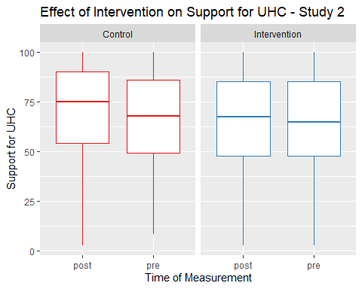

Our control condition improved support for UHC while our intervention did not

## Proposed Mediational Effects

Tingley et al., (2014) as well as Frazier & Tix (2004) describe the necessary procedures to test mediational hypothesis. For H2a, we posit that perceived equity as a mediating variable for the causal effect of our intervention condition on support for UHC. The initial step in fitting our mediation model is to have our measure of perceived equity modelled as a function of our intervention condition and all covariates. Next, we have our support for UHC outcome variable modelled as a function of our measure of perceived equity (the proposed mediator) and the same set of covariates we used in our previous step. Finally, we generate 1000 bootstrap simulations using a quasi-Bayesian monte-carlo method based on normal approximation to estimate the average causal mediational effects and average direct effects of perceived equity on support for UHC. In support of H2a, the effect of our explicit HBP on support for UHC was partially mediated via the perceived equality of the HBP. We observed a statistically significant effect of experimental condition on our proposed mediating variable, perceived equality, t(820) = -3.551 ,p < .001. Perceived equality decreased 10.49 points in our intervention condition compared to our control condition. Furthermore, we observed a statistically significant effect of perceived equality on our outcome variable, support for UHC, t(821) = 18.243 ,p < .001. Support for UHC increased by .424 points for every point of increase in perceived equality. After computing 1000 bootstrapped samples, our estimate for our indirect effect was -2.72 (95% CI = -4.43, -1.03), thus our estimated average causal mediation effect is significant (p = 0.002). In opposition to H2b, the effect of our explicit HBP on support for UHC was not mediated by the comprehensibility of the HBP. This is since we do not see a significant effect of experimental condition on our proposed mediating variable, comprehensibility, t(820) = -0.805 , p =0.421.

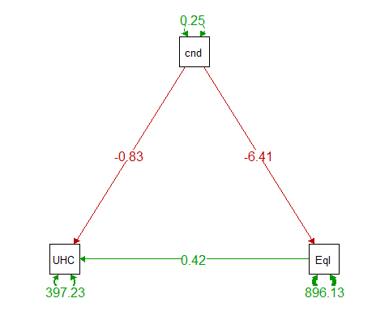

Path Diagram showing the effect of condition on UHC Support and Percieved Equity

We chose to illustrate our proposed mediational relationship using a path diagram, as seen in [Figure here]. Again, in support of H1a, we see that there is a mediational relationship between condition and UHC through the effect of perceived equity. Increased perceived equity increases support for UHC, and the control condition both has greater support for UHC, as well as greater perceived equity.

## Moderating Effect of Numeracy

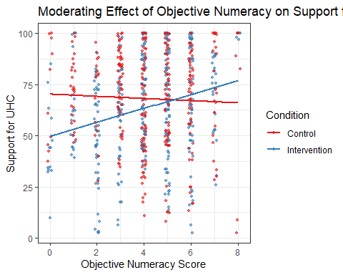

We see a clear interaction between objective numeracy and the intervention

In partial opposition of H3, in [Table here], we see that there is no direct effect of subjective numeracy, ß = 1.784, t(624) = 1.551 ,p = .121, or significant interaction with experimental condition, ß = 1.411, t(624) = -0.867 ,p = .386, on support for UHC. Given the lack of direct effect and interaction, we were unable to find evidence of a moderating effect of subjective numeracy on support for UHC.

In partial support of H3, in [Table here], we see a direct effect of objective numeracy on support for UHC, ß = 1.43, t (684) = 2.904, p = 0.004. Support for UHC increases by 1.43 points for each point of increase on the Rasch Numeracy Scale. Furthermore, we also see a significant interaction between the effect of objective numeracy and the condition, ß = 2.78, t (624) = 3.99, p < .001. In our intervention condition, support for UHC increases by an additional 2.78 points for each point of increase on the Rasch Numeracy Scale. Objective, but not subjective, numeracy has a significant effect on support for UHC, with an even greater effect for subjects in our intervention condition.

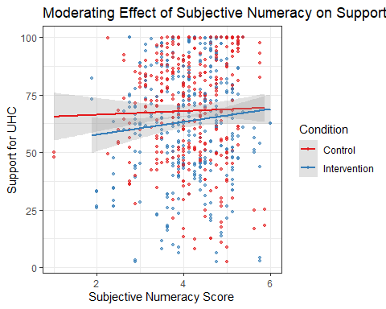

We see no interaction between subjective numeracy and the intervention

## Qualitative results

Analyzing our free-response question, we found very similar responses to those in Study 1, but with some significant differences . Unlike Study 1, no participants reported difficulty with comprehending the new activity or confusion regarding the instructions and procedures.. Several participants however reported difficulty regarding the decision making required in the task itself. Some examples include:

“it was much more difficult than I thought it was going to be; I had to compromise points in some places to be able to get at least basic coverage in other areas”

“It’s hard for me to think about people having to pick and choose which parts of healthcare they’ll have access to when they’re all important. It makes me wish healthcare would be reformed for the good of everyone and not just those who can afford it.”

Additionally, replicating what we found in Study 1, 18.4% of intervention condition participants and 8.7% of control condition participants found the activity particularly interesting and fun. Given that the purpose of the intervention is to increase engagement, this is a positive outcome. An example of these responses:

“Interesting that my answers changed. I would be interested in seeing someone against Universal Health Care make a study, too.”

“Enjoyed it, overall I believe that there should be Universal Health Care, but I did not realize how complicated it was. This exercise showed me how complicated it will be if the US decides to go through with something like this.”

# Discussion

Our primary goal for Study 2 was to provide a pseudo-replication of our Study 1 hypothesis, with improved experimental materials intended to reduce confusion. Hypothesis 1 was not supported by the results of our intervention. We recorded the exact opposite effect; our intervention was less effective at increasing support for UHC than our control. Additionally, we directly measured our two proposed mediating relationships through Hypothesis 2. We believed that greater perceived equity would increase support for UHC (H2a). We also believed increased comprehensibility would increase support for UHC (H2b).

Hypothesis 2a was supported by the results of our intervention. The data indicated that perceived equality was a significant mediator for support for UHC. Using the bootstrapping method outlined by Tingley and colleagues (2014), we estimated that perceived equality is a significant mediator on support for UHC not just in our sample, but in the population. Our intervention condition was perceived to have lower equity than our control, which partly explains why our control condition had a greater increase in support for UHC, in opposition to Hypothesis 1. Hypothesis 2b was not supported by the results of our intervention; There was not a significant effect of experimental condition on comprehensibility. Lastly, we intended to determine if objective and subjective numeracy would moderate the effect of intervention condition on support for UHC in Hypothesis 3. Hypothesis 3 was partially supported by the results of our intervention. We saw a significant effect of objective, but not subjective numeracy, on support for UHC. Furthermore, we found a significant interaction between the effect of objective numeracy and our intervention condition. Subjects low in objective numeracy had greater support for UHC in our control condition compared to our intervention condition, in opposition to Hypothesis 1. Yet subjects high in objective numeracy had greater support for UHC in our intervention condition compared to our control condition, in support of Hypothesis 1. This indicates that our initial Hypothesis 1 is valid, but only for subjects with higher objective numeracy.

In line with previous research, we did find that the majority (69% of our subjects) of our participants found the HBP acceptable (Goold et al., 2000; Danis et al., 2004). We also replicated the positive level of support found by Huebner et al. (2006), but in a non-medical student population. However, we only partially replicated previous work on the effects of active versus passive instruction (Haidet et al., 2004; Michel et al., 2009; Weiger et al., 2019). We found that active learning was more effective, but only for subjects with higher numeracy. Hadiet and colleagues (2004) found that active instruction was effective for mathematically focused content, we believe that this is due to high objective numeracy further improving the effect of active instruction. The large advantage that the more numerate have is exacerbated even further by active instruction using numbers. Addressing the lack of impact for low-numeracy subjects is necessary to bridge the understanding gap created by the high complexity of UHC.

Study 2 provided mixed evidence regarding our mediational hypothesis. Both perceived equality as well as understanding of UHC strongly predicted support for UHC. However, our experimental intervention lowered perceived equality and neither condition influenced comprehensibility. It is plausible that there is partial mediation of perceived equity on support for UHC. However, our intervention did not successfully improve perceptions of equity. This is a repudiation of previous research by Hurst et al., (2018) regarding the HBP framework being perceived as fair. We were able to determine that comprehensibility is a strong predictor for support for UHC, but further research is necessary to determine how best to improve comprehensibility.

We had no a-priori assumptions regarding the impacts of numeracy. Peters (2020) writes that objective numeracy measures the ability to use knowledge of basic probability and mathematics, as well as to communicate and interpret mathematical information. In comparison, subjective numeracy represents confidence in ability to understand mathematics, and the preference for numbers over words. Plausibly, those who lack objective numeracy, may find it difficult to engage in calculating and trading off options. Alternatively, more numerate individuals could engage more in a numbers-based activity, paying more attention and thus resulting in a larger effect.

In our intervention, the main source of difficulty was ‘agonizing’ over distribution of resources for an ideal health plan. This is intentional, making realistic and difficult choices akin to those for health-care officials is the purpose of the exercise. Additionally, many individuals in our intervention condition expressed support and appreciation for the exercise. This provides further evidence that the HBP based active intervention was indeed successful at improving engagement. However, one consistent category of responses across both conditions expressed belief that the exercise was either politically motivated or had a strong intentional bias in its construction. To address this, we could present a HBP for a UHC in comparison to a set of standard private insurance plans. Additionally, measuring political affiliation could allow us to directly examine the effect of political motivation on support for UHC.

# Limitations

Study 2 recruited participants from a large midwestern university located in a medium sized midwestern city. This limits the amount of generalization to other populations. The design of Study 2 required familiarity with internet and online survey platform technology, which may make it difficult to adapt to older or less tech-savvy populations. Some subjects indicated in the free-response section that the information presented was biased towards support for UHC and did not paint the whole picture of arguments supporting our current private care system. Therefore, we were unable to derive potential insights comparing to see if positive messaging on private health care would reduce support for UHC.

# Future Directions

The lowest-hanging fruit is a replication of the study, providing evidence of our proposed mediating relationship and moderating effects, on a group that more closely mimics the insurance buying public. This would provide additional external validity, as the primary decision-makers around health insurance are not university students. Another extension for replications of this research would be to developing a structured plan for qualitative analysis such as semantic text analysis, LIWC specifically.

There are several modifications of the experimental materials that would be of interest to examine. One would be determining if different resource availability would have greater or lesser support. If there is no significant difference, that would perhaps provide evidence indicating that the structure of an HBP could have has greater salience in determining approval versus simply the objective healthcare options available.

Another valuable extension would be to measure additional moderating variables. Political orientation and polarization are two variables explicitly referenced in our free response section by participants. We could also design experimental material that explicitly promotes ‘standard’ private health insurance as it exists in the US or compare to negative messaging on ‘standard’ private health care without having positive information about UHC.

The most valuable extension would be to determine how to increase support for UHC with individuals that have lower objective numeracy. Low objective numeracy is common in the US population. Having an intervention that only works to increase support for UHC in individuals with high-objective numeracy is problematic as we would want to impact the whole of the population. Some considerations could be a simplified version of the exercise, or to clearly indicate the trade-offs using a computer activity that does not explicitly reference numbers or calculation.

# Appendix A

### Experimental Materials for Study 1

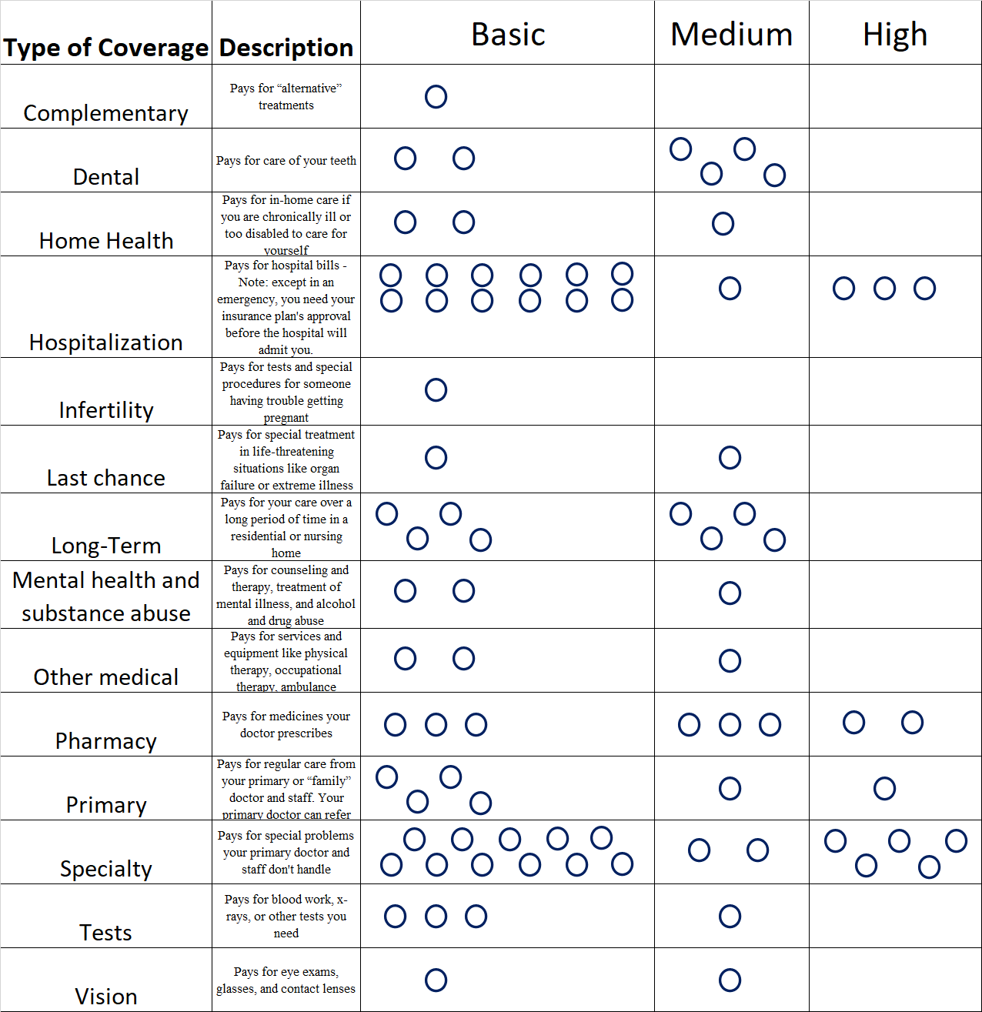

Blank CHAT Sheet for ‘Active’ intervention condition

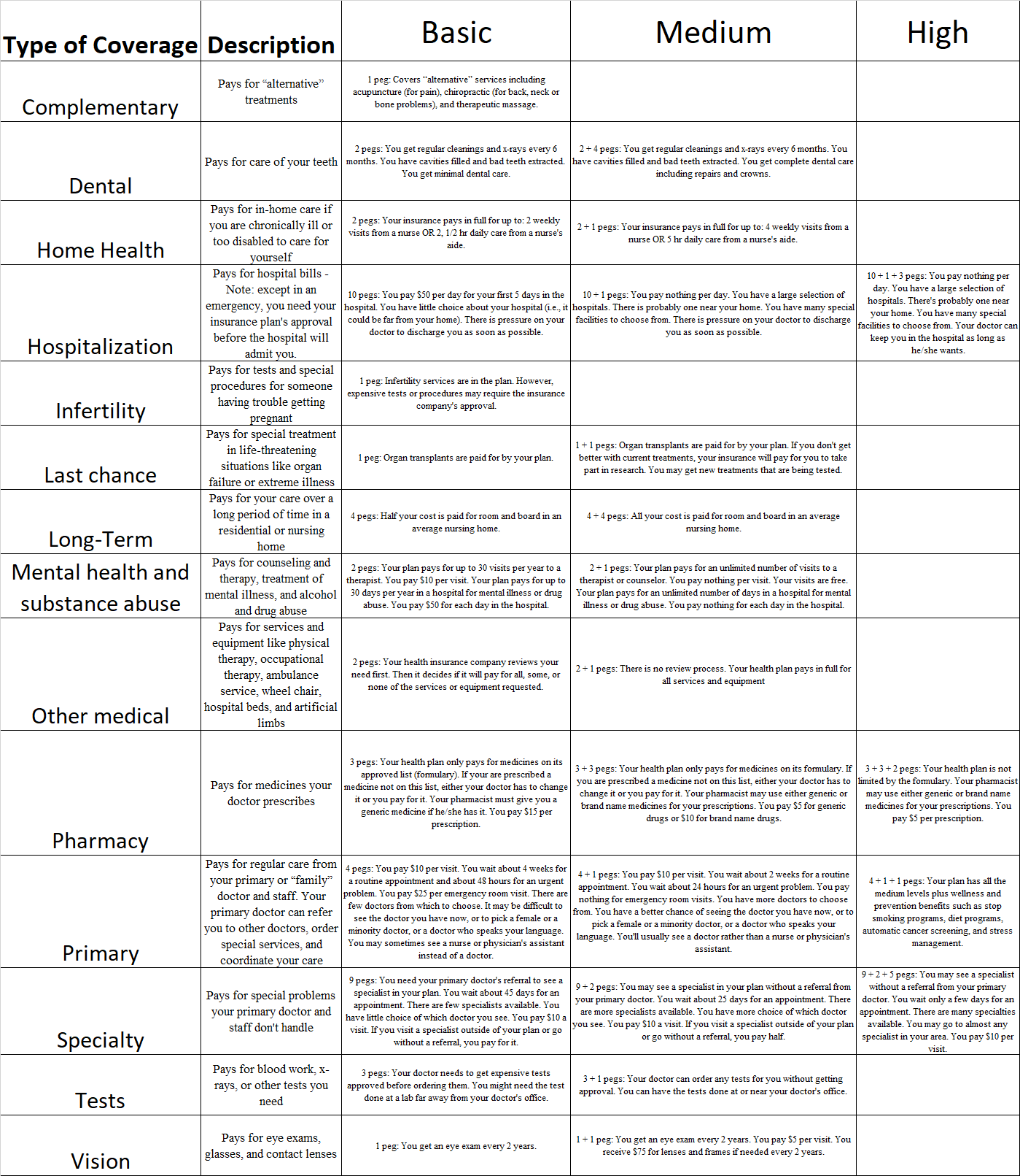

Legend for ‘Active’ intervention condition

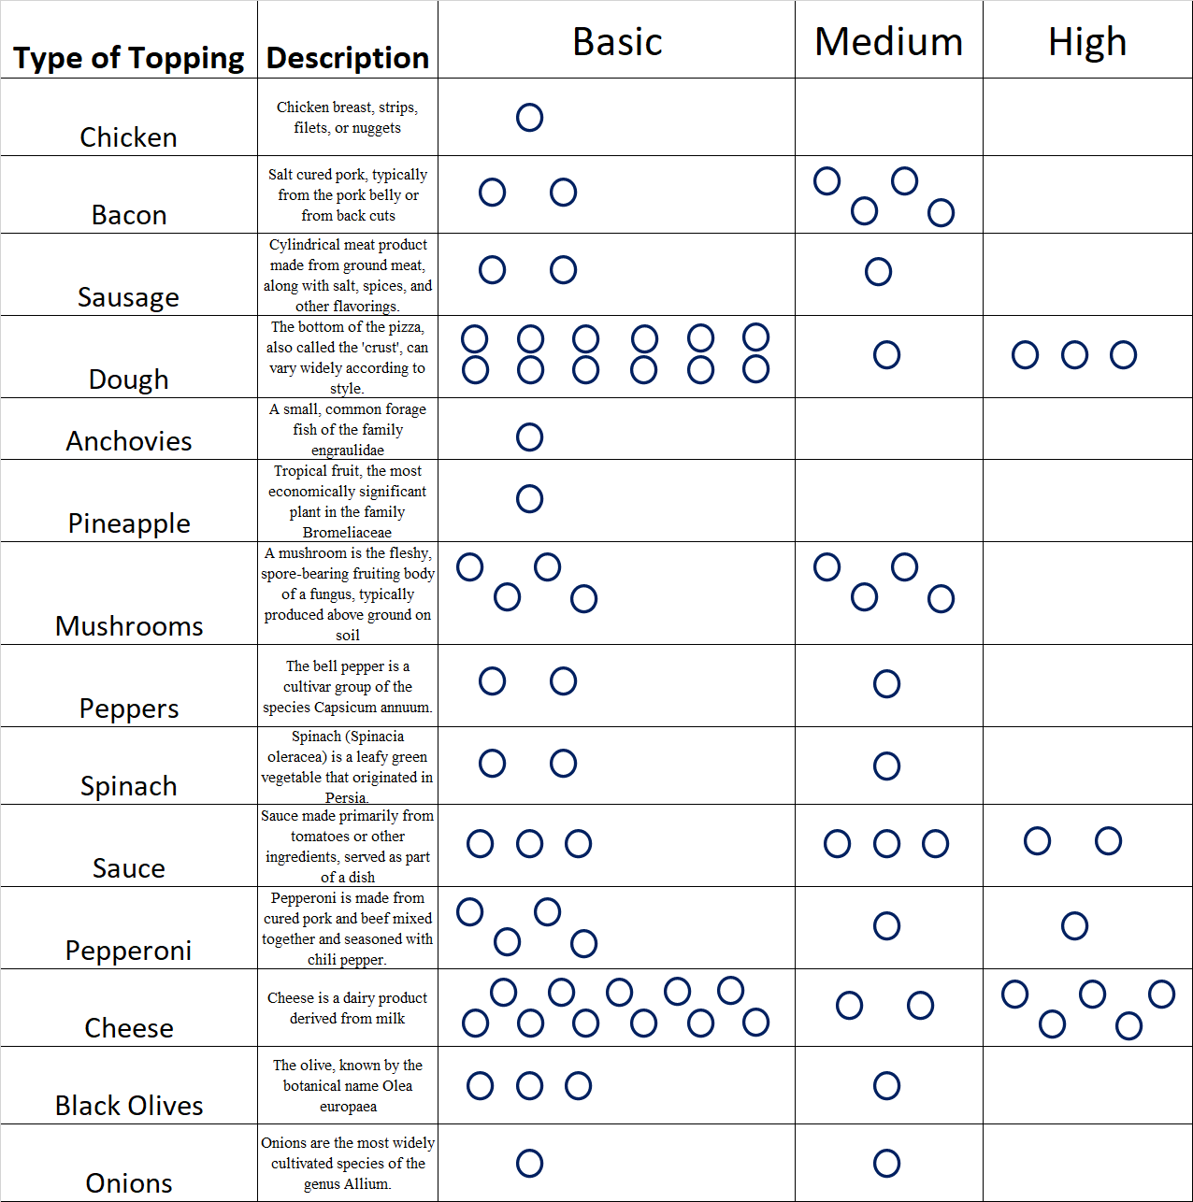

Blank CHAT Sheet for uninformative control condition

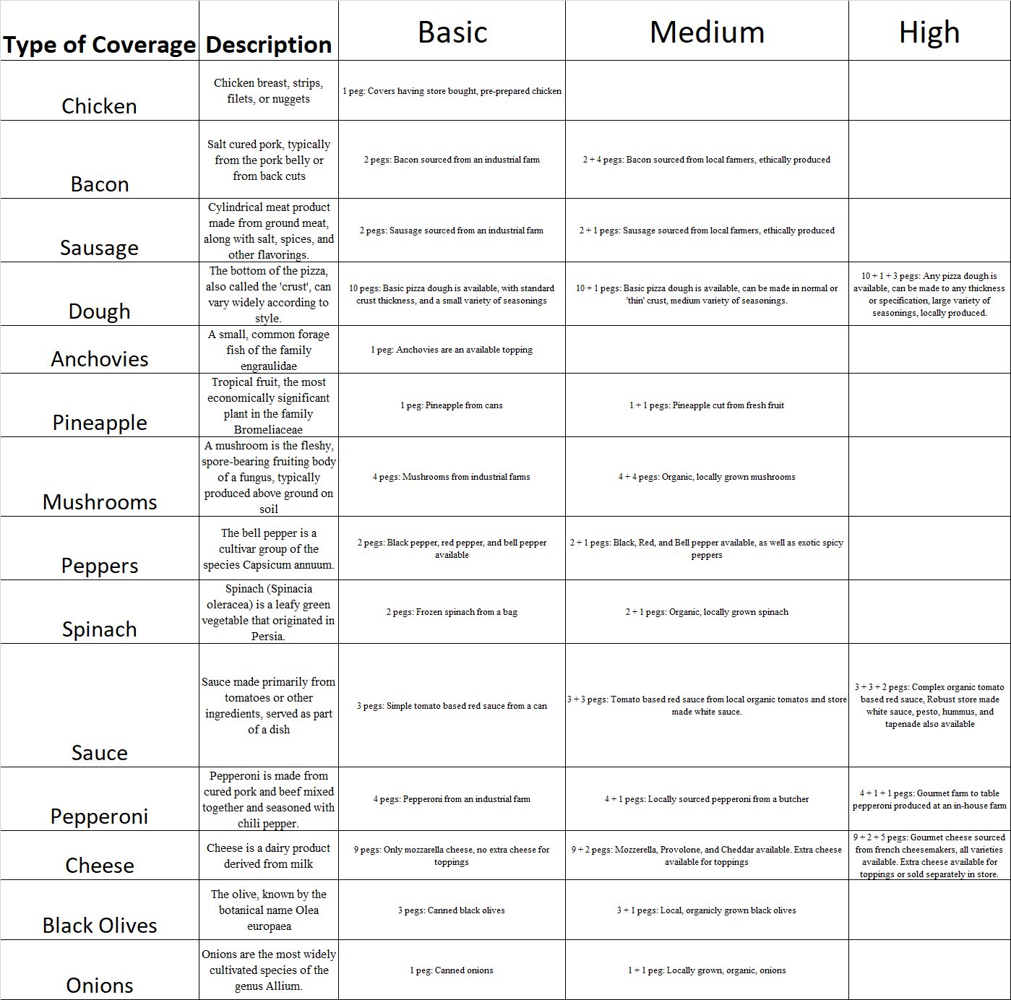

Legend for uninformative control condition

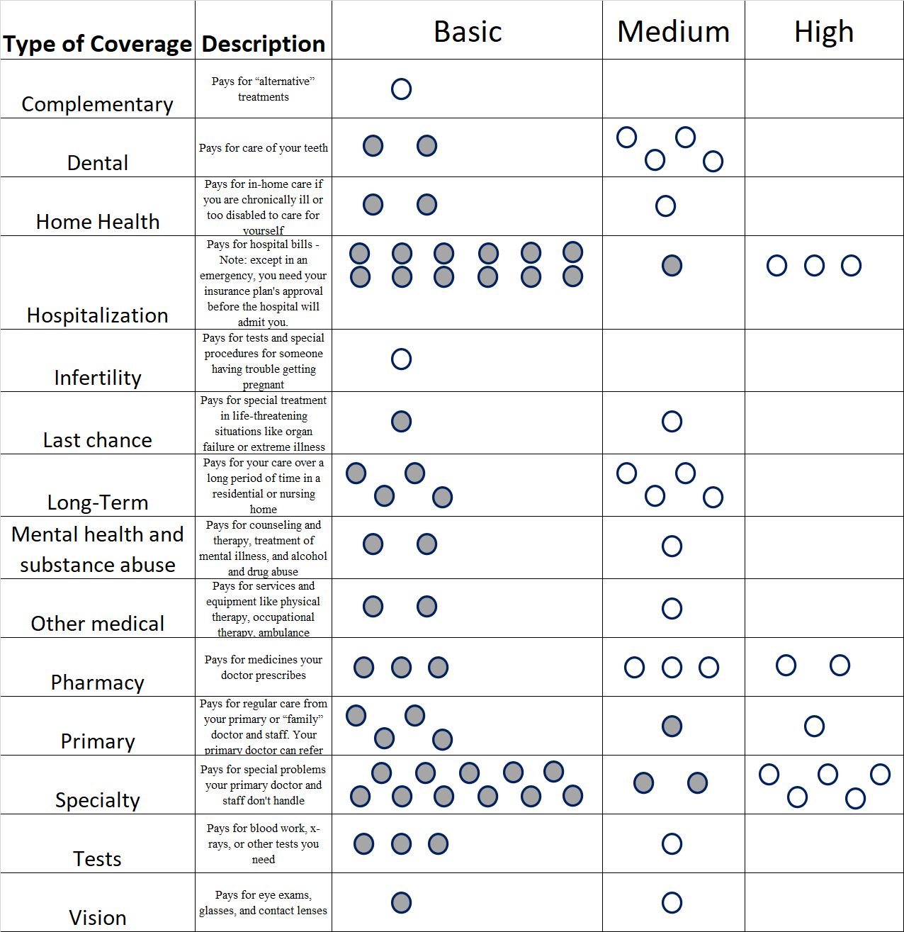 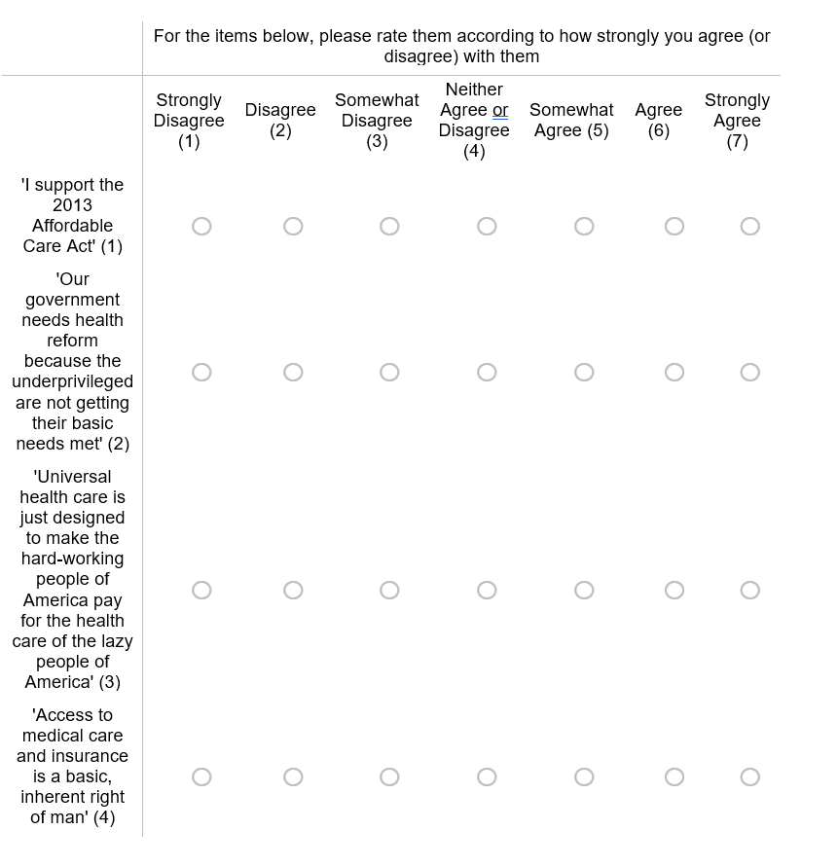

# Appendix B

### Experimental Materials for Study 2

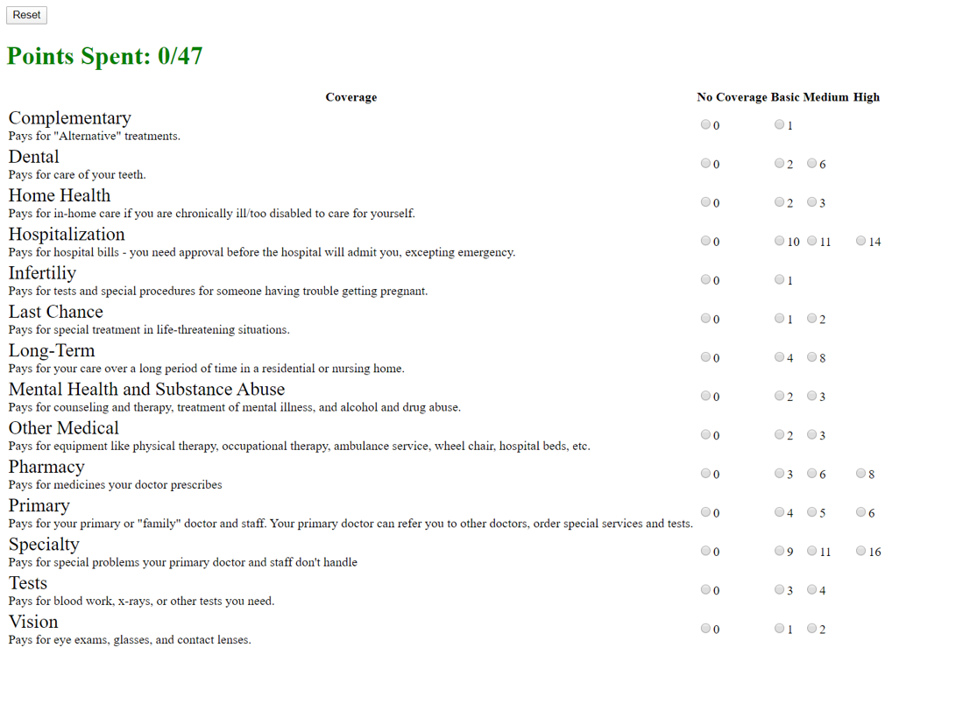

Screenshot of Web Exercise for Intervention Condition

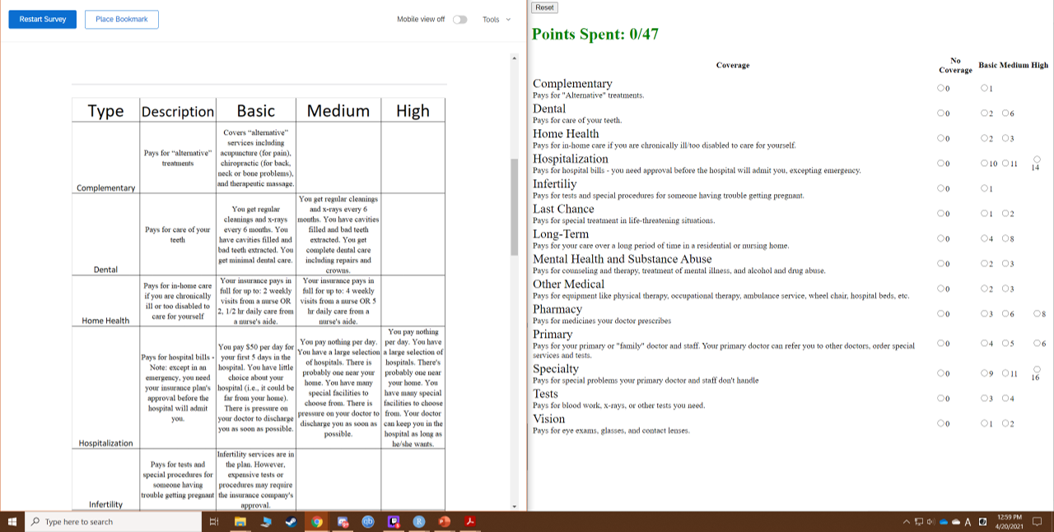

Screenshot showing legend and web exercise for intervention condition

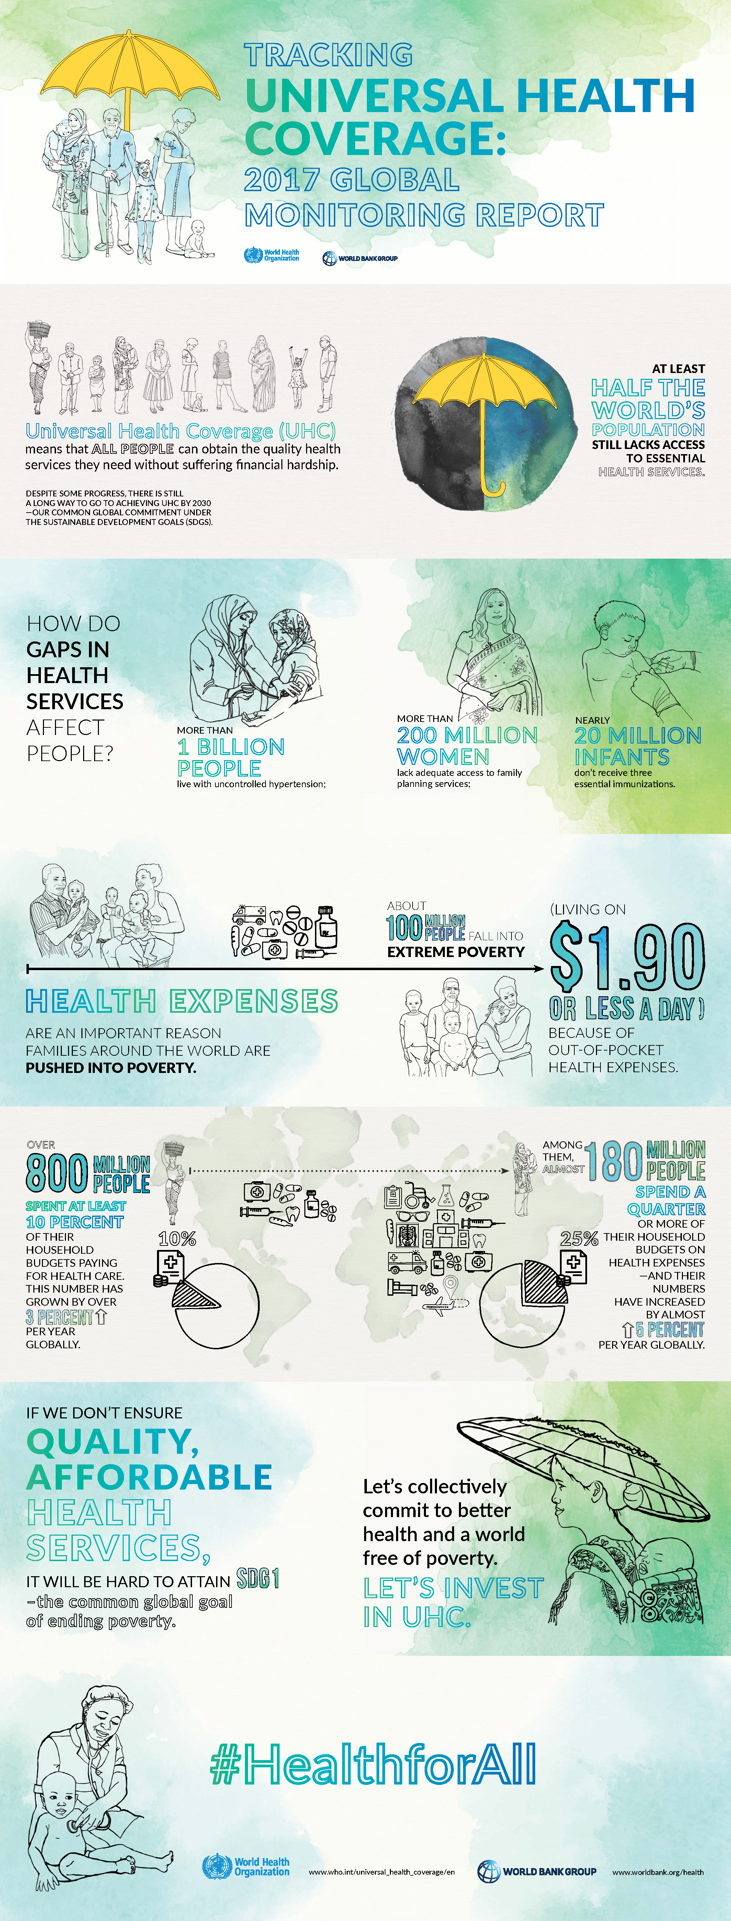

1st Infographic for control condition

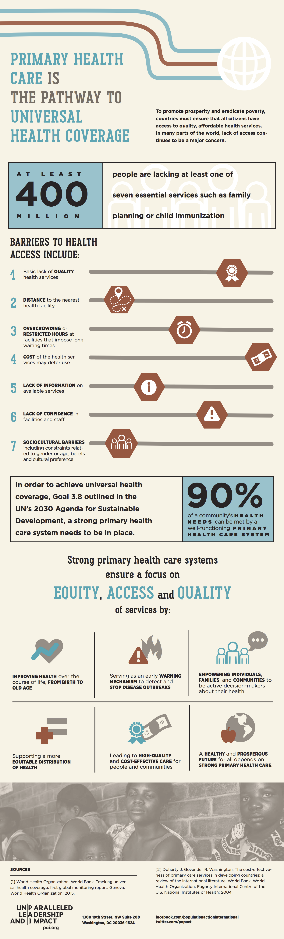

2nd Infographic for control condition

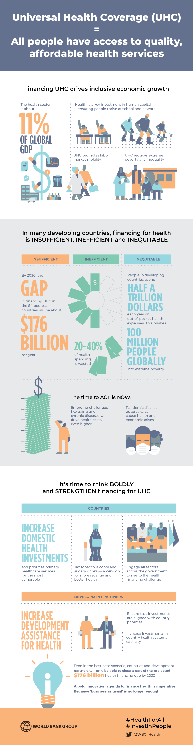

3rd Infographic for control condition

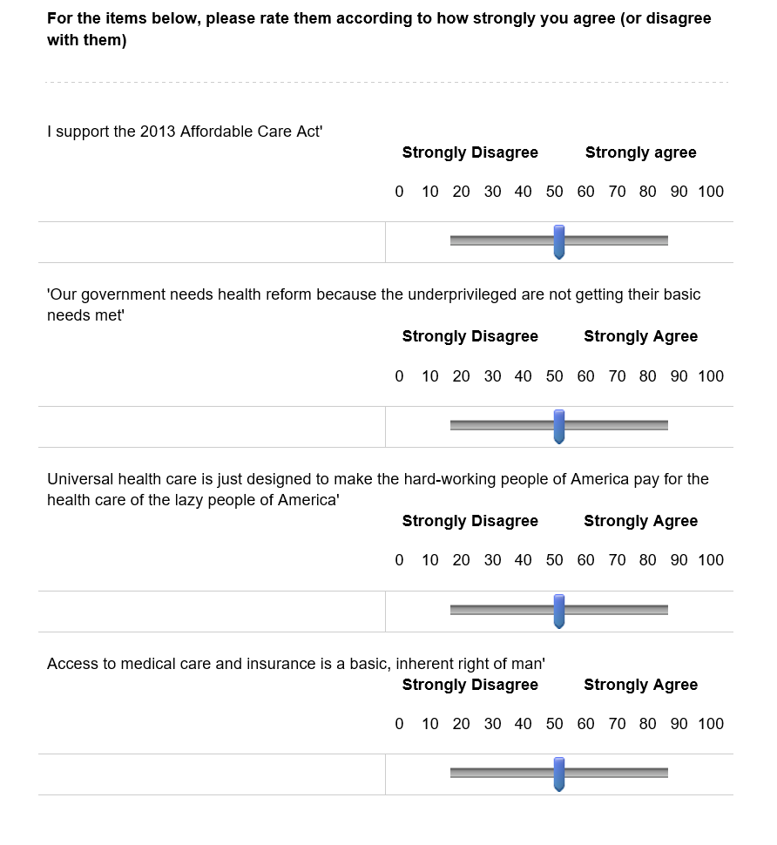

Support for UHC Measure - Scale and Item wording

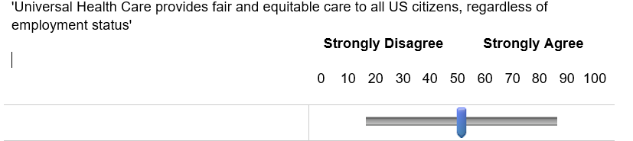

Percieved Equity Measure - Scale and Item wording

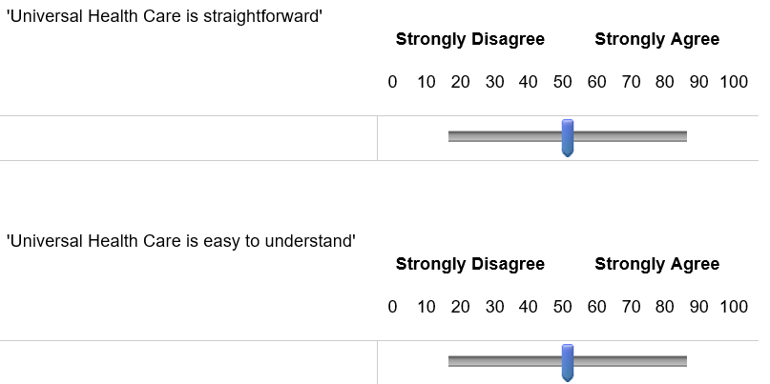

Percieved Understanding Measure - Scale and Item wording

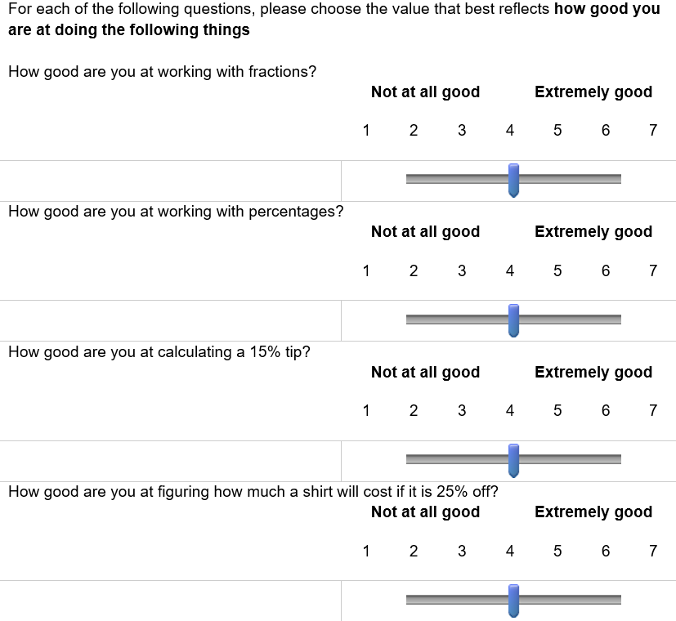

Subjective Numeracy Scale Part 1 - Scale and Item wording

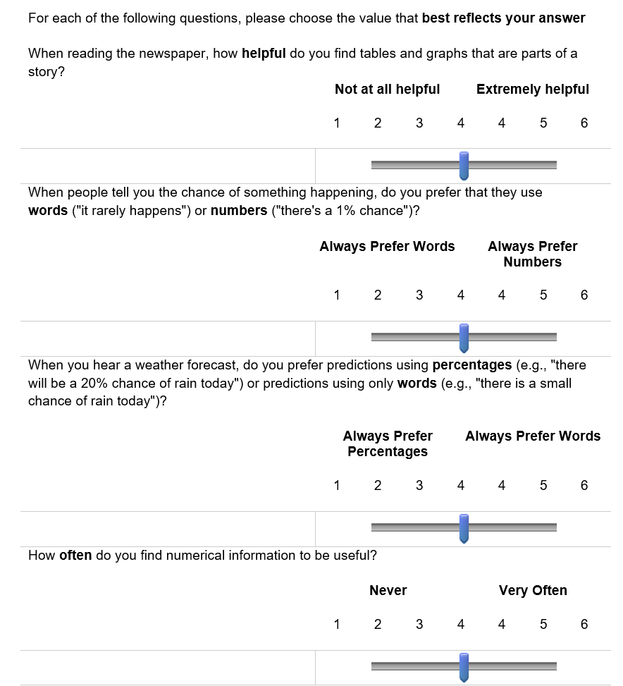

Subjective Numeracy Scale Part 2 - Scale and Item wording

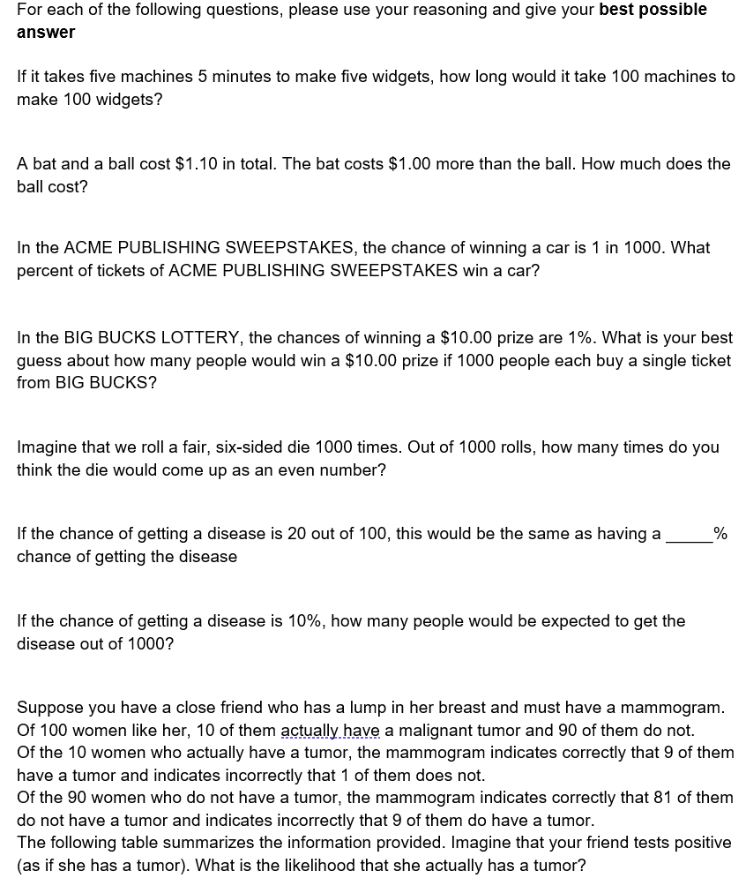

Rasch Numeracy Scale (Objective Numeracy) - Item wording